Hi Welcome to Structures
I am very sorry but due to the mysterious nature of structures we can't show you anything here!!
without being registered for the course!!
Well...O.K., if you really want to see it:
just register for the course now
see you at class!!

What Are Steel Moment Frames?
Most modern high-rise buildings and many mid- and low-rise buildings rely on steel moment frames to resist lateral loads arising from winds or earthquakes. Lateral loads on a building caused by wind are externally applied and easy to visualize. Conversely, lateral loads from earthquakes result from internal inertial loads that develop as the ground, and therefore the building’s foundation, accelerates. This is similar to the force that a passenger standing on a bus feels when the bus accelerates. In the case of a building, inertial forces are primarily at the floor levels, where the weights are concentrated.
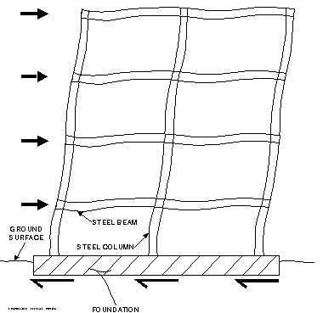
Steel moment frames consist of beams and columns joined by a combination of welding and bolting. They resist lateral loads through bending of the frame elements as illustrated in the top figure. In the case of wind loads and moderate earthquakes, steel frames designed using the current building code are intended to remain elastic. In other words, when the loading ceases, all of the steel beams and columns constituting the frame are expected to return to their original position without any permanent deformation
This is not the case for a major earthquake, however. During strong ground motion, the steel members are expected to behave in a ductile manner: stretching and absorbing energy. After the earthquake, permanent deformation of the steel-frame members is expected. Several special detailing provisions in the current code are intended to ensure ductile performance; however, as explained in the accompanying article, this performance was not achieved during the Northridge Earthquake.
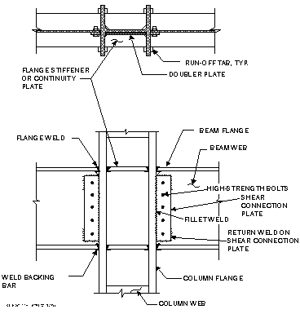
The bottom figure identifies the various components of a typical moment connection. These or similar connections are used to join all of a moment frame’s members. In all moment connections, the beam flanges are welded directly to the column, thereby providing bending resistance. Beam webs are usually bolted to the column using shear connection plates. It should be noted that, normally, and especially in more recent construction, few of a building’s beams and columns are used as components of moment frames. Consequently, most of the steel framing is joined only by simple bolted connections and does not contribute to the lateral-load resistance.
Steel moment frames consist of beams and columns joined by a combination of welding and bolting. They resist lateral loads through bending of the frame elements as illustrated in the top figure. In the case of wind loads and moderate earthquakes, steel frames designed using the current building code are intended to remain elastic. In other words, when the loading ceases, all of the steel beams and columns constituting the frame are expected to return to their original position without any permanent deformation.
This is not the case for a major earthquake, however. During strong ground motion, the steel members are expected to behave in a ductile manner: stretching and absorbing energy. After the earthquake, permanent deformation of the steel-frame members is expected. Several special detailing provisions in the current code are intended to ensure ductile performance; however, as explained in the accompanying article, this performance was not achieved during the Northridge Earthquake.
The bottom figure identifies the various components of a typical moment connection. These or similar connections are used to join all of a moment frame’s members. In all moment connections, the beam flanges are welded directly to the column, thereby providing bending resistance. Beam webs are usually bolted to the column using shear connection plates. It should be noted that, normally, and especially in more recent construction, few of a building’s beams and columns are used as components of moment frames. Consequently, most of the steel framing is joined only by simple bolted connections and does not contribute to the lateral-load resistance.
Return to Steel's Performance in the Northridge Earthquake.
Return to EQE REVIEW Fall 1994 contents page.
Go to EQE International's home page.

